**Introduction To Database Management Systems (Lab 1)**

**Problem:**

1. The Structur'e for the Table “STAFF” is given below. EMP_NUM is the primary key, EMP_FNAME and EMP_LNAME cannot be NULL. Create the table as per the structure.

|  |  |
| --- | --- |
| **ATTRIBUTE (FIELD) NAME** | **DATA DECLARATION** |
| EMP_NUM | CHAR(3) |
| EMP_LNAME | VARCHAR(15) |
| EMP_FNAME | VARCHAR(15) |
| EMP_INITIAL | CHAR(1) |
| EMP_HIREDATE | DATE |
| JOB_CODE | CHAR(3) |

1. Insert data into the “STAFF” Table according to the image given below. EMP_INITIAL can be NULL but FNAME and LNAME cannot. Also, remember that HIREDATE is of DATE type. Write a select all Query that can display all data in the table which looks like this.

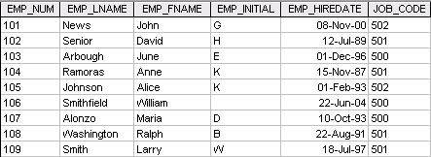

1. Write SELECT queries that show :
   1. All details of staff with EMP_HIREDATE before 1 January 1997.
   2. All details of staff with JOB_CODE equal to 500.
   3. EMP_LNAME and EMP_FNAME of staff with EMP_INITIAL equal to K.
   4. EMP_NUM of staff with JOB_CODE less than 500.
   5. All details of staff with EMP_NUM between 102 and 105.